Problem Chosen: Smart Safety and Assistance System for Sanitation Workers of Solapur Municipal Corporation
Problem context
The sanitation staff are forced to work in highly dangerous environments such as sewer pipes, underground drainage systems, and manholes. These areas are known to have dangerous gases such as methane and hydrogen sulfide, low oxygen levels, high humidity, and biological hazards such as snakes and insects. At present, there is no effective system in place to continuously monitor the safety of the workers or send immediate notifications in case of emergencies.

Many times, accidents happen because of the delayed detection of dangerous conditions and the absence of real-time communication between the workers and the concerned authorities of the municipalities. Since there is no real-time monitoring, the emergency services are unable to act promptly, thus increasing the chances of severe injuries or death.

This issue affects not only the sanitation workers but also the concerned authorities of the municipalities, the emergency services, and the public safety departments. Hence, there is an urgent need for a smart monitoring system that can ensure continuous safety monitoring and prompt emergency responses.

Objectives
The primary objectives of the proposed system are :

- Real-time location tracking detection by GPS/LoRa technology.
- Supporting emergency services and enhancing protection for workers.
- Establishing effective long-range communication in underground or distant areas.
- Waterproof wearable technology.
- Preventing workers from entering dangerous environments by sending an early warning.
- Monitoring workers’ physical health and sending notifications during health issues.
- Minimizing rescue time by sending real-time information about workers.
- Improvising coordination between workers and the emergency services of the concerned municipality.
- Real-time monitoring dashboard for the concerned municipality.

Constraints
- Processing power of embedded systems, accuracy of sensors.

- The system should be able to operate in water, humidity, dust, and high temperatures.

- Limited processing power and memory.

- Environmental interference and calibration constraints.

- The system needs to be able to transmit data in underground and low-signal regions.

- The system needs to be easy to handle and maintain.

- The system needs to be lightweight (less than 600g), compact, and comfortable to carry for the worker.

- The system should cost less than ₹6,000.

- The battery life should be a minimum of 8 hours.

Functions
- Detection of dangerous gases that are present in the worker’s environment.

- Tracking the motion of the worker.

- Processing data from the sensor using microcontrollers.

- Displaying warning messages at monitoring stations when dangerous conditions are detected.

- Receiving and storing data at the base station for analysis and monitoring.

- Tracking the location of the workers during working hours.

- Transmitting data using LoRa communication for long-range connectivity.

- Powering the system using a battery.

- Waterproofing the system to protect it from water and dust.

- Detection of oxygen levels in the environment to ensure worker safety.

Problem Chosen: Smart Safety and Assistance System for Sanitation Workers of Solapur Municipal Corporation
Proposed Solution
The proposed system is a wearable safety device intended for the protection of sanitation workers in hazardous sewer environments. The system is designed to detect toxic gases such as methane, hydrogen sulfide, and carbon monoxide, as well as monitor the health parameters of the workers, and alert the control room in real time using LoRa communication. The device is waterproof and portable.

Early-Stage Solution Architecture

Sl.No | Subsystem Name | Functionality
1 | Sensor subsystem | This includes gas sensor,temperature sensor,GPS module,motion sensor and SOS button to collect safety-related data.
2 | Processing subsystem | Arduino mega acts as the main controller to read ,process,and manage sensor data.
3 | Communication subsystem | LoRa module provides long-range,low-power wireless communication between the worker device and central monitoring dashboard by sending location and data.
4 | Monitoring subsystem | A central dashboard collects and displays real-time data for analysis and monitoring.
5 | response subsystem | Municipal authorities receive alerts,and emergency teams take accurate action.

List of subsystems :
- Sensor subsystem
- processing subsystem
- communication subsystem
- Monitoring subsystem
- response subsystem

Subsystems Interaction matrix

From subsystem | Gas sensor subsystem | Temperature subsystem | GPS subsystem | SOS button subsystem | Arduino mega controller | Communication subsystem (LoRa/GSM)
Gas sensor subsystem | - | - | - | - | Data (gas concentration level) | -
Temperature subsystem | - | - | - | - | Data (worker body temp) | -
GPS subsystem | - | - | - | - | Data (emergency signal ON/OFF) | -
SOS button subsystem | - | - | - | - | - | Data ( Alert transmission)
Arduino mega controller | control signal (sensor power/status) | control signal | control signal | control signal | - | Data (processed safety information)
Communication subsystem (LoRa/GSM) | - | - | - | - | Data (receives processed data) | -

Architecture Diagram
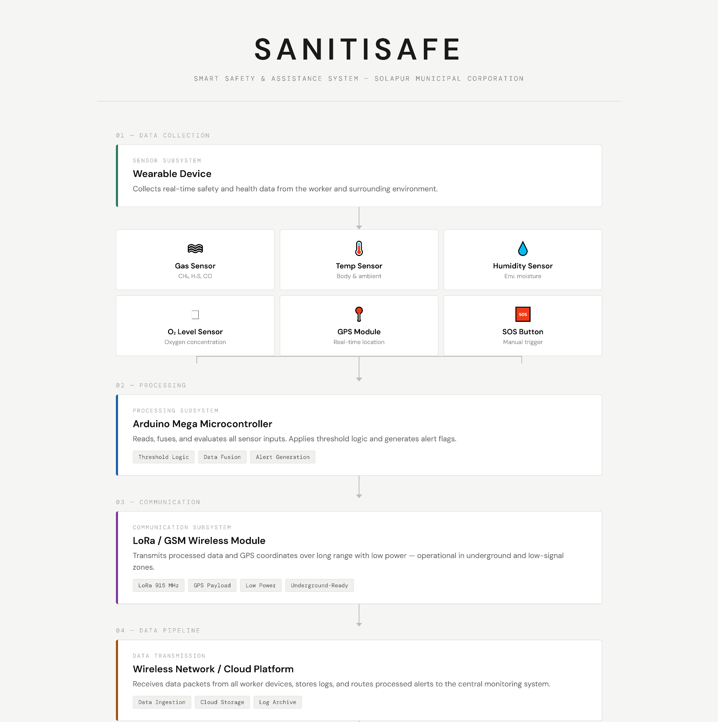

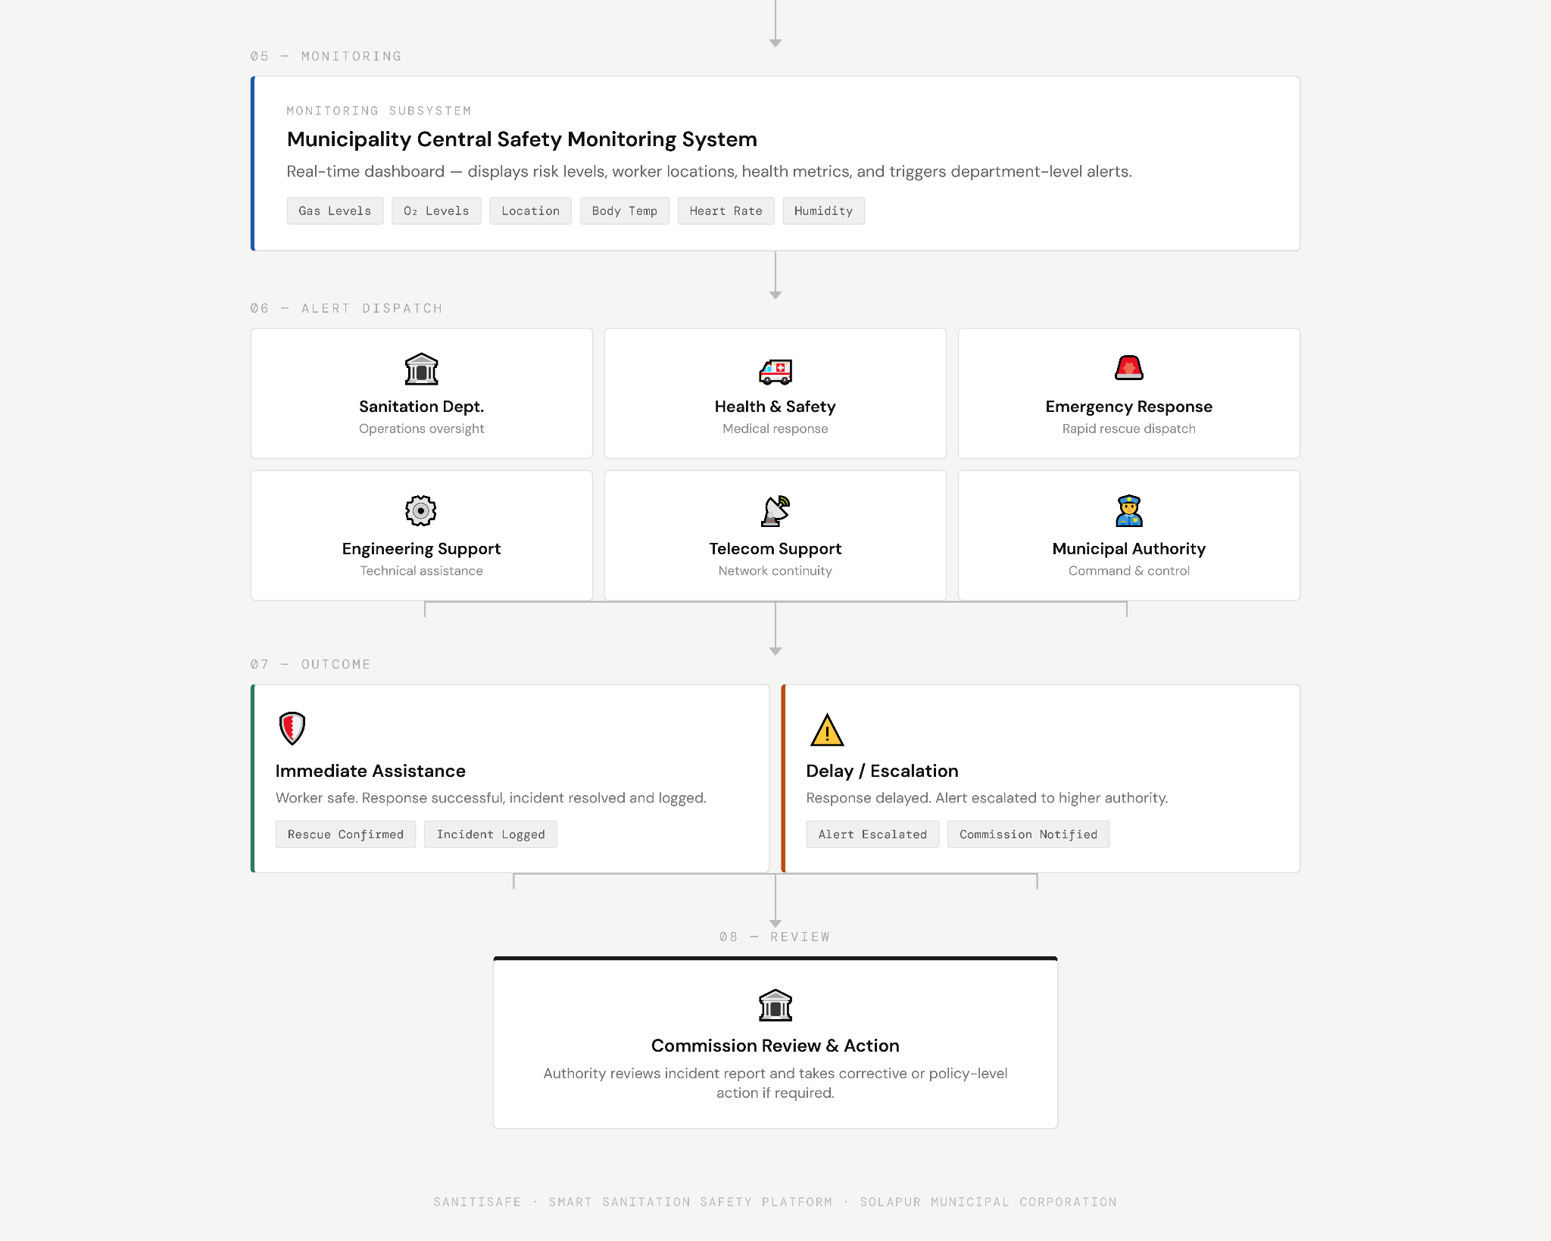

Team Information
Team name: : SANITISAFE |  |  | Institute code:QM
Institute name: KG REDDY COLLEGE OF ENGINEERING AND TECHNOLOGY
City: Moinabad |  |  | State: Telangana
Mentor Details
Mentor name: Gudapati Lakshmi Bhavani
Contact number: 9000633008 |  |  | Email: lakshmisrinivas.2010@kgr.ac.in
Participant Details
SN | Participant name | Program | Sem | Contact number | Email
1 | Turangi Shiva Ganga | Electronics and Engineering | 2-2 | 8897264039 | shivaganga997@gmail.com
2 | Zoha Mehrin | Electronics and Engineering | 2-2 | 8328058130 | zohamehrin2124@gmail.com
3 | Vadla Manoj kumar | Electronics and Engineering | 2-2 | 7337018581 | vadlamanojkumar45@gmail.com
4 | Taduru Shashank | Electronics and Engineering | 2-2 | 8712323413 | 24qm1a0455@kgr.ac.in
5 | Mangarai Rajeshwari | Electronics and Engineering | 2-2 | 6304541673 | jayaramulujayaramulu680@gmail.com
Note: The above details will be used for certificate generation. Please ensure accuracy.
Declaration
We hereby declare that the work titled “Smart Safety and Assistance System for Sanitation Workers of Solapur Municipal Corporation ” submitted for SAMVED-2026 is the original outcome of our team’s efforts.
The work has been carried out by us under the guidance of the undersigned mentor and is neither copied from any source nor generated using artificial intelligence (AI) tools.

Place: Hyderabad, Moinabad
Date: 20/02/2026
Team Leader Name: Turangi Shiva Ganga
__________________________
Mentor Name: Gudapati Lakshmi Bhavani
__________________________

